**9. ReactJS – HOL**

**1. List the features of ES6**

* let and const for block-scoped variables
* Arrow functions (()=>{})
* Template literals using backticks `
* Destructuring assignment for arrays/objects
* Default parameters in functions
* Classes and Inheritance
* Promises
* Modules using import and export
* New data structures: Set, Map

**2. Explain JavaScript let**

* Used to declare block-scoped variables
* Cannot be redeclared in the same scope
* Hoisted but not initialized

**3. Differences between var and let**

| **Feature** | **var** | **let** |
| --- | --- | --- |
| Scope | Function-scoped | Block-scoped ({}) |
| Redeclaration | Allowed | Not allowed in same scope |
| Hoisting | Hoisted, initialized as undefined | Hoisted but uninitialized |

**4. Explain JavaScript const**

* Block-scoped like let
* Must be initialized at declaration
* Value cannot be reassigned (but object properties can be changed)

**5. Explain ES6 class fundamentals**

class Person {

constructor(name) {

this.name = name;

}

greet() {

return `Hello, ${this.name}`;

}

}

**6. Explain ES6 class inheritance**

class Student extends Person {

constructor(name, grade) {

super(name);

this.grade = grade;

}

}

**7. Define ES6 arrow functions**

const add = (a, b) => a + b;

* Shorter syntax
* No own this, arguments, super

**8. Identify set(), map()**

* Set: Collection of unique values
* Map: Key-value pairs with keys of any type

**9. Create a React Application named “cricketapp” with the following components:**

1. **ListofPlayers**

* **Declare an array with 11 players and store details of their names and scores using the map feature of ES6**
* **Filter the players with scores below 70 using arrow functions of ES6.**

1. **IndianPlayers**
   1. **Display the Odd Team Player and Even Team players using the Destructuring features of ES6**
   2. **Declare two arrays T20players and RanjiTrophy players and merge the two arrays and display them using the Merge feature of ES6**

**Display these two components in the same home page using a simple if else in the flag variable.**

**Step 1:** Open Terminal and create a new react project

***npx create-react-app cricketapp***

***cd cricketapp***

**Step 2:** Create Components ListofPlayers.js and IndianPlayers.js

**ListofPlayers.js**

import React from 'react';

const ListofPlayers = () => {

  const players = [

    { name: "Virat", score: 85 },

    { name: "Rohit", score: 95 },

    { name: "Rahul", score: 55 },

    { name: "Pant", score: 45 },

    { name: "Hardik", score: 70 },

    { name: "Ashwin", score: 60 },

    { name: "Bumrah", score: 50 },

    { name: "Jadeja", score: 90 },

    { name: "Dhawan", score: 65 },

    { name: "Shami", score: 40 },

    { name: "Surya", score: 88 },

  ];

  const filteredPlayers = players.filter(player => player.score < 70);

  return (

    <div>

      <h2>All Players with Scores</h2>

      <ul>

        {players.map((player, index) => (

          <li key={index}>{player.name} - {player.score}</li>

        ))}

      </ul>

      <h3>Players with Scores Below 70</h3>

      <ul>

        {filteredPlayers.map((player, index) => (

          <li key={index}>{player.name} - {player.score}</li>

        ))}

      </ul>

    </div>

  );

};

export default ListofPlayers;

**IndianPlayers.js**

import React from 'react';

const IndianPlayers = () => {

  const T20players = ["Kohli", "Rohit", "Pant", "Hardik"];

  const RanjiTrophy = ["Pujara", "Rahane", "Sarfaraz", "Iyer"];

  const allPlayers = [...T20players, ...RanjiTrophy];

  const oddTeam = allPlayers.filter((_, index) => index % 2 === 0);

  const evenTeam = allPlayers.filter((_, index) => index % 2 !== 0);

  return (

    <div>

      <h2>Merged Players</h2>

      <ul>

        {allPlayers.map((player, index) => (

          <li key={index}>{player}</li>

        ))}

      </ul>

      <h3>Odd Team Players</h3>

      <ul>

        {oddTeam.map((player, index) => (

          <li key={index}>{player}</li>

        ))}

      </ul>

      <h3>Even Team Players</h3>

      <ul>

        {evenTeam.map((player, index) => (

          <li key={index}>{player}</li>

        ))}

      </ul>

    </div>

  );

};

export default IndianPlayers;

**App.js**

import React from 'react';

import ListofPlayers from './components/ListofPlayers';

import IndianPlayers from './components/IndianPlayers';

function App() {

  const flag = true;

  return (

    <div className="App">

      <h1>Cricket App</h1>

      {flag ? <ListofPlayers /> : <IndianPlayers />}

    </div>

  );

}

export default App;

**Step 3:** In terminal, type ***npm start*** and this will run your code.

**OUTPUT:**

**When flag = true**

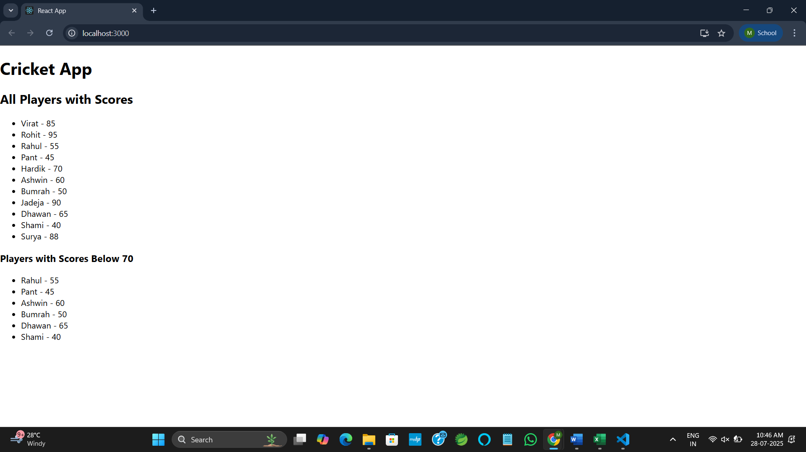

**When flag = false**

